Organise and Describe Data

# **Probable Output**

* **Servo Motor Control** - Turns on the servo motor
* **Alert LED Signal** – Warn pet store staff about unconsumed food

# Input Description

|  |  |  |  |
| --- | --- | --- | --- |
| **Input Name** | **Type** | **Notation** | **Example Values** |
| Feeding Time | Continuous – Time | FTime | 13:00, 19:00 |
| Weight of the food tub | Continuous – Integer | BWt | 100 gram, 200 gram |
| Current System Time | Continuous – Time | Time | 13:20, 19:45 |

To represent system inputs in the form of a logical diagram the input can be represented as follows

|  |  |  |
| --- | --- | --- |
| **Input Name** | **Notation** |  |
| Is it feeding time | *FT (High)* | System only operated if *FTime* is High |
| Is the feeding bowl empty | BEmp (Low) |  |
|  |  |  |

# Output Description

|  |  |  |  |
| --- | --- | --- | --- |
| **Input Name** | **Type** | **Example Values** | **Notation** |
| Servo Motor Control | Discrete - Boolean | 1 (High), 0 (Low) | Mot |
| Alert LED Signal | Discrete - Boolean | 1 (High), 0 (Low) | Alert |

# Truth Table

|  |  |  |  |
| --- | --- | --- | --- |
| **FT** | **BEmp** | **MOT** | **ALERT** |
| 0 | 0 | 0 | 1 |
| 0 | 1 | 0 | 1 |
| 1 | 0 | 0 | 0 |
| 1 | 1 | 1 | 1 |

**ALERT = FT . BEmp // FT *AND* BEmp**

**MOT = FT . BEmp // FT *AND* BEmp**

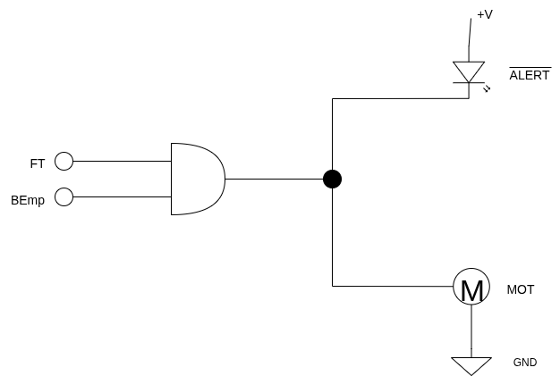

# Operational Parameter

The system turns on the motor or alert LED if it is feeding time. So, we can ignore value of *FTime* as it should be 1 (High) for system to operate.